**User Manual**

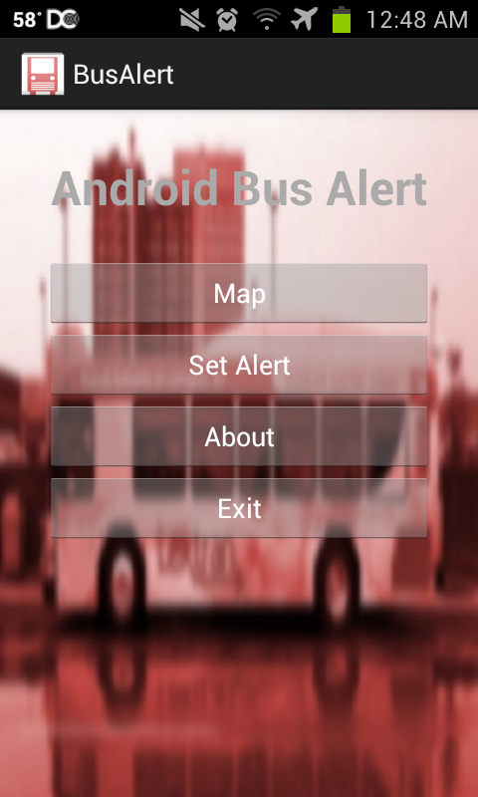BusAlert is a very straightforward app, but I will explain how to use the functionality it has. The main menu of the app is what will launch the first time that you start it after installing.

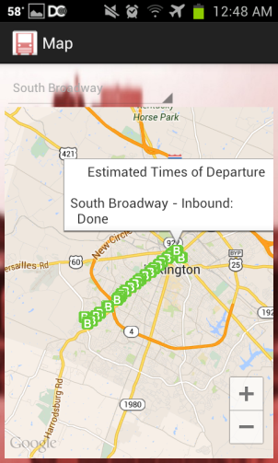The “Map” button will take you to our interactive map. Once there, you will have a drop down box that allows you to select the route that you want to view. Once you select a route, the map will query Lextran and draw the stops on that route onto the interactive map. At this point, you can click on any of the stop icons to see the estimated arrival of buses coming to the stop.

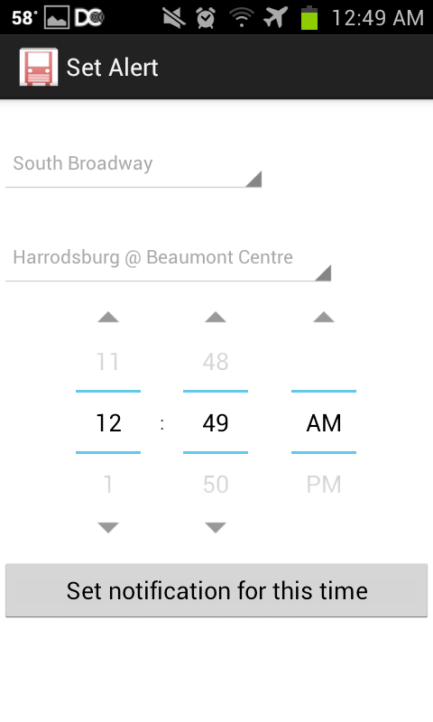You can now continue selecting routes, or use the back button on your phone in order to go back to the main menu. If you click on the “Set Alert” button you will see the notification creation screen.

You now have another drop down for route. Once you select a route, the drop down box with populate with the stops on that route. You now select one of those stops and a time. After selecting all of those options and pressing the notification button you will be alerted that a notification has been set. Bit your back button to close the notification alert.

That covers the main features of our application. If you select the “About” button on the menu screen you will see a brief description of Bus Alert. If you select “Exit” it will close BusAlert. This concludes the guide of BusAlert!